**9-channel relay control board**

|  |  |
| --- | --- |
| Author | Gijs Jackers |

Content

1 Introduction 1

2 Material and methods 2

2.1 Materials 2

2.1.1 Resistors 2

2.1.2 Capacitors 2

2.1.3 Sockets 2

2.1.4 LCD 2

2.2 Schematic representation 3

2.3 Methods 3

2.4 Bill of materials 4

3 Results 4

3.1 Operation: 4

3.2 Use of the 9-channel relay control board: 5

4 Discussion 8

4.1 Difficulties: 8

4.1.1 Footprint of T1 and T2: 8

4.1.2 LCD socket: 8

4.1.3 IC1 was not connected to the 5V circuit: 8

4.2 Reflection 8

5 Reference list 8

# Introduction

This application note covers the topic “9-channel relay control board”. This board is made up of 9 relays which can be individually controlled by the pushbuttons on the circuit board. The pushbuttons are each linked with an designated relay and will toggle between the on and off position. The LCD screen shows the current position of each relays. The usage of the relay board is for testing electronic components. Furthermore, in this application note there is more info about material and methods, the achieved results and some difficulties that occur during the project.

# Material and methods

## Materials

### Resistors

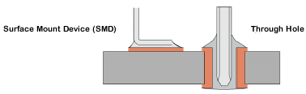All resistors on the board are SMD (Surface Mount Devices) components and not through-hole components. Figure 1 shows the deference between SMD and through-hole components.

Figure 1 difference between SMD and through-hole

The footprint of the through-hole components used in the relay board setup cannot be found in Altium Designer so by replacing the through-hole components with SMD components the footprint problem is solved.

### Capacitors

The capacitors that are used are through-hole components, because they are easily to find and lower in cost. These capacitors are also available in SMD components, but are more difficult to solder, because they have a very small footprint. Also, through-hole components are easier to replace if a fault should happen and a capacitors would break.

### Sockets

On the relay board there are 2 different kind of sockets used: one for ICs and one for the microcomputer. The difference between these 2 is that the sockets for the ICs are narrower as well as less tall and the sockets for the microcomputer are two separate strips of pin sockets.

### LCD

To get an idea of what is happening an LCD (liquid-crystal display) is used. The display will show if the relays are on/off.

## Schematic representation

Figure 2 SCHEMATIC REPRESENTATION

## Methods

Start off with deciding which design of circuit board to create. A project with a schema is a good begin. In the second step it is recommended to learn to work with Altium designer. Check for datasheets of components that are in the project. Observe different websites with each other for the best price possible. Examine the difference in footprints and the advantages. Learn how to assemble an Altium Library. See what the delivery time is of different components. Next step is to design the PCB. The intension in this step is to choose where each component is being placed on the circuit board and to see if the datasheet matches the footprint and the holes for the through-hole components. Step 5 is where the placement and the soldering of the components takes place. Connecting components incorrectly is possible at this step therefore it is useful to have some extra components. Capacitors is an component that will break if placed incorrectly. After assembly comes testing. In this step looking for mistakes is essential. On to designing the case. The goal in this step is to design a case for the circuit board. The final step is to finalize the project and an to evaluate.

## Bill of materials

Figure 3 BILL OF MATERIALS

The bill of materials consists of 28 different components and a total of 78 components with a total price of 76,64 euros.

# Results

## Operation:

The 9-channel relay control board functions as follows. The board is power by an adapter that feeds 12 volts and 1.5 ampere in the DC power connector which powers all the components. After the power connector there is a security for when instead of 12V there comes in -12V. This is to prevent components from breaking. The brains of the whole board is the IC2. The IC gets the input from the buttons and calculates which button is connected to which relay and gives a signal to the relay to toggle between the on and off state. However when using the IC2 you first need to flash the component with the software provide by the company. There are several possibilities for flashing an IC. The method used for this project is flashing with a pickit3. Picture 4 shows a Pickit3 which is used for programming the component.

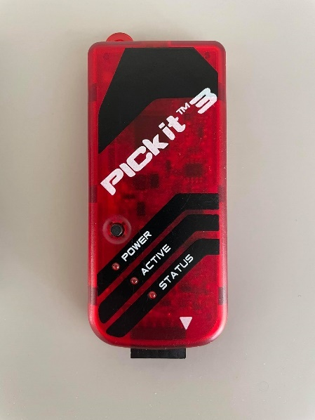

Figure 4 picture of Pickit 3

The pickit3 can be bought in a package with the PIC seat. Figure 5 below shows the PIC seat.

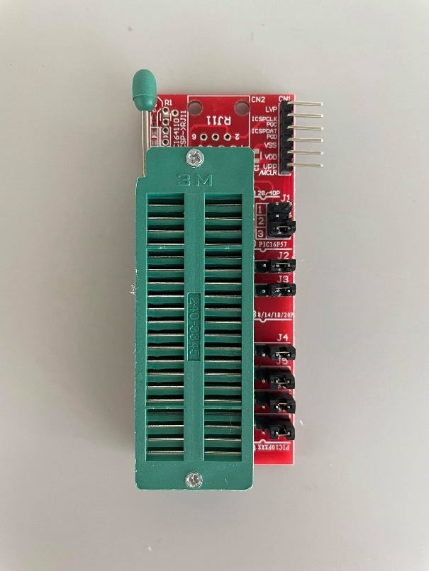

Figure 5 PIC seat for the Pickit3

The seat is a board that makes contact with every single pin of the IC while programming. When the IC2 is flashed it can be placed in his socket on the board. The LCD which is also controlled by IC2 displays the status of each individual relay. The relays used on the relay board are single pole single throw 10 ampere power relays that can handle a load op to 12 volt DC. The relays used on this board are latching relays which means the relay maintains its state after actuated. The single pole single throw (SPST) relays has a total of four terminals. Two of this terminals can be connected or disconnected. The relays are accessible by the screw terminal. The terminal wraps the wire directly under the head of the screw which forces it to make contact with the metal plate. Each screw and metal plate are connected to a different pin of the relay.

## Use of the 9-channel relay control board:

A use of the relay board is to test high voltage components because a relay is able to open or close contacts using a relatively small electrical power in the coil of the electromagnet.

For example, in outdoor lights with a motion detector a relay is used because the motion detection system works on 24V and the lamp is powered at 230V.

Figure 6 shows the electrical schematic in Altium.

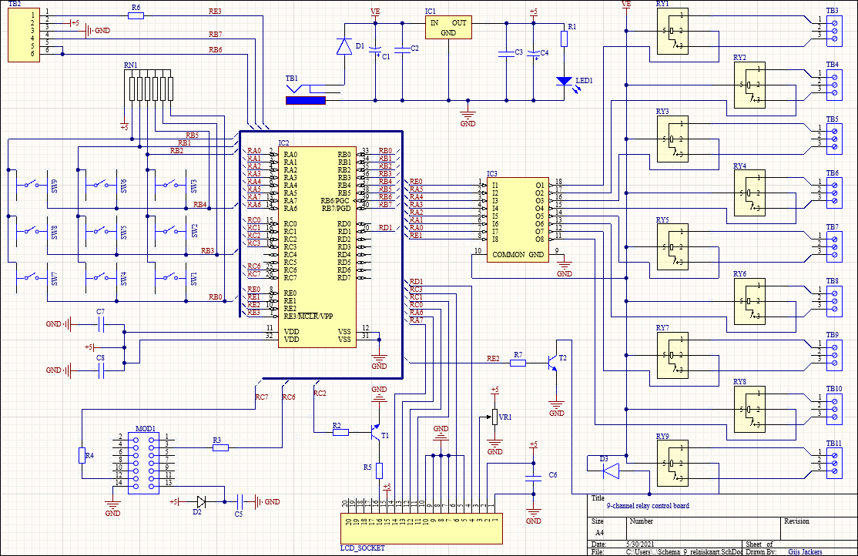

Figure 6 Electrical schematic in Altium

Figure 7 shows the PCB design in Altium.

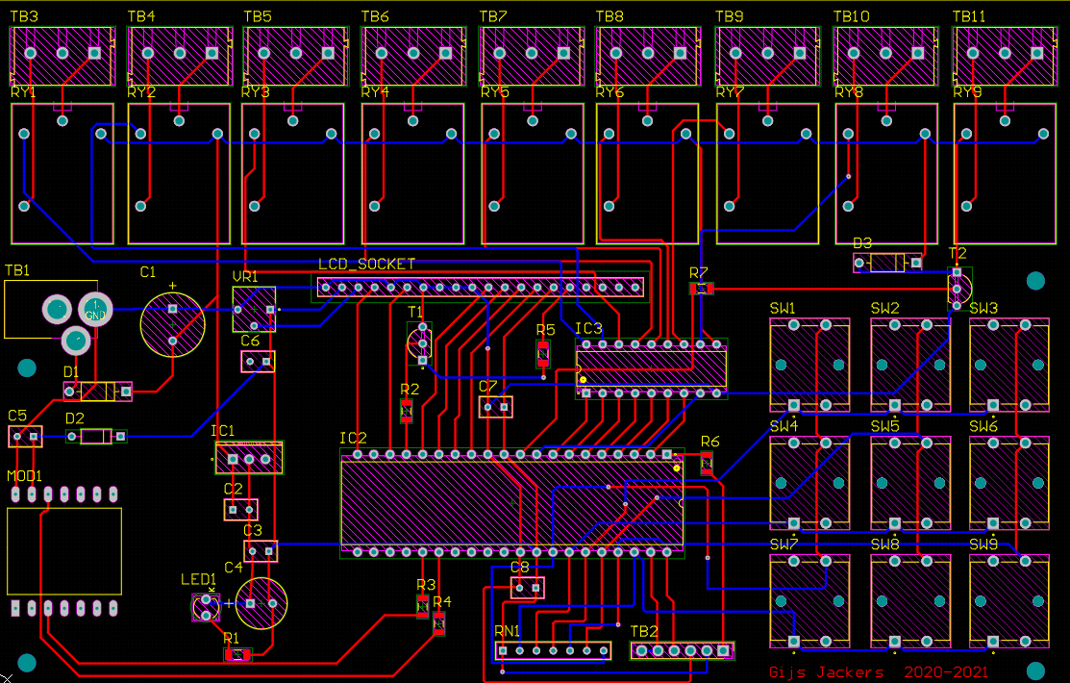

Figure 7 PCB design in Altium

Figure 8 shows the finalized PCB design.

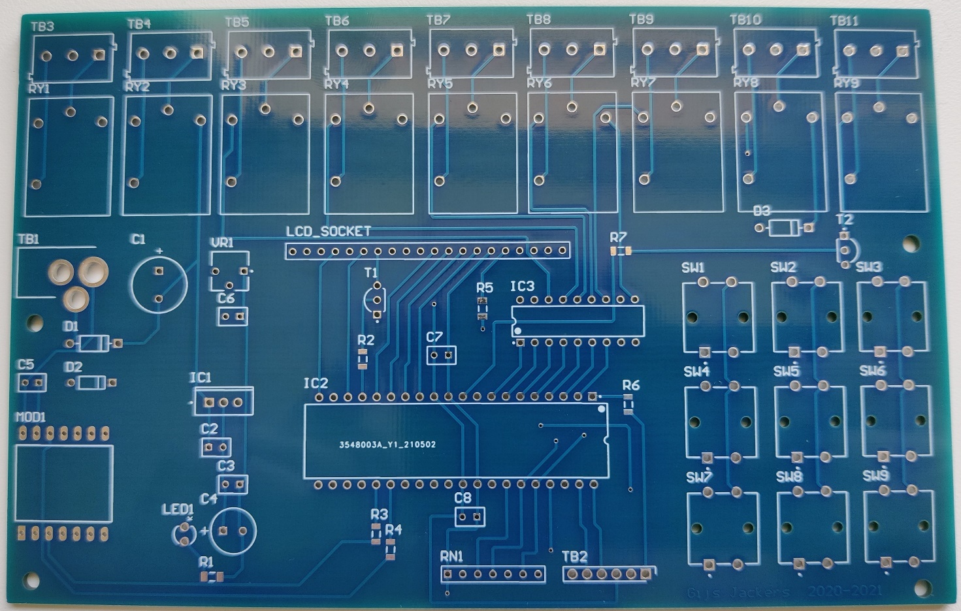

Figure 8 Empty print

Figure 9 shows finalized product.

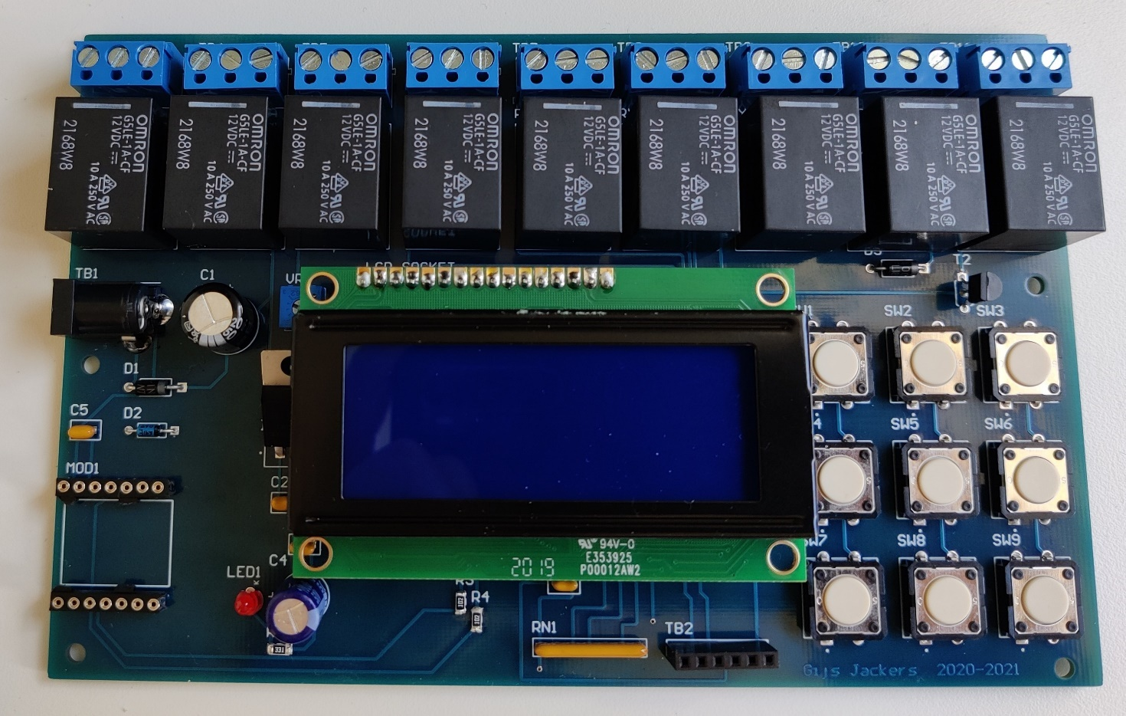

Figure 9 Finished relay board

# Discussion

## Difficulties:

### Footprint of T1 and T2:

The original holes in the footprint of conductor T1 and T2 were too compact. The holes were too close together for JLCpcb to manufacture. To prevent this the holes in the footprint needed to be spaced further apart. There are two solutions for this problem, solution one: take the footprint of T1 and T2 and change the layout with footprint manager to a different footprint that can be made by rule wizard. Solution two: find a different footprint in component list for a conductor with the same specifications.

### LCD socket:

The magazine where the idea of the 9-channel relay control board came from used an twenty pin socket for the LCD. The LCD only has sixteen pins so there are 4 pins untouched, but the magazine suggested in using an twenty pin socket. Finding a footprint for the socket was complicated, but finding the right component to buy was even more complex. The problem what happened was that the LCD didn’t fit in the ordered socket because the ordered socket was an IC socket. The solution: soldering two eight pin socket on the board. Two times an eight pin socket instead of an sixteen pin socket is just because of the fact that there were spare components from school.

### IC1 was not connected to the 5V circuit:

IC1 has tree pins VE, GND, 5V but only VE and GND were connected on the PCB design in Altium. Without the 5V the board did not power on. The solution: connecting the 5V pin of the IC by soldering a wire to the nearest 5V pin. The closest 5V pin was the 5V pin of the C3.

## Reflection

Everything went smoothly and nothing went horribly wrong.

# Reference list

|  |  |
| --- | --- |
| [1] | Elektor. [Online]. Available: https://www.elektormagazine.com/labs/9-channel-relay-control-board-with-pc-interface-130549#&gid=1&pid=4. |